Key Metrics that needs to be included
- Total Products Purchased
- User Category having highest Product Purchase
- Country having Highest Product Purchase
- Highest Logins by Region

Dashboard Layout - using PowerPoint
- KPIs should be placed at the Top
- Charts should be places below the KPIs
- Filter should be placed at the Right Side of the Dashboard
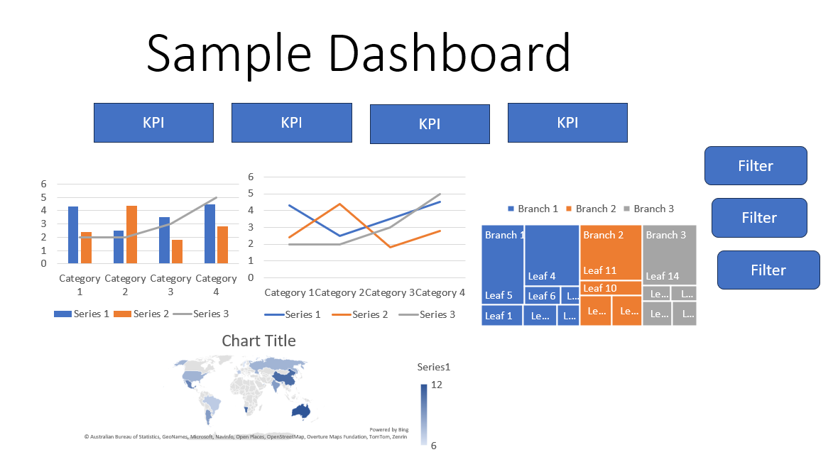
Note: Dashboard Automation Script is available in Source Code folder

Subscription Model Feasibility:
3 data key points that Manufacturers would find it valuable
- Products Purchased based on Country
- Products Viewed by Region
- Services Used on Quarterly Basis Region Wise

Kindly Refer to the Sample Dashboard for Manufacturers below.

